Table 1. 75mm crushed concrete average percent passing and Kelowna specifications.
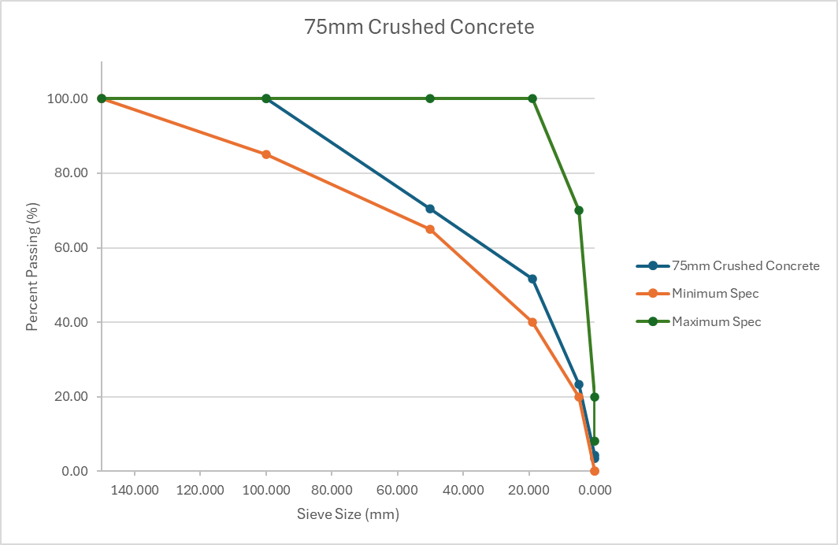
Figure 1. Relationship between percent passing (%) and sieve size (mm) for the average value of 75mm crushed concrete compared to City of Kelowna specifications.

Table 2. 19mm crushed asphalt average percent passing and Kelowna specifications.
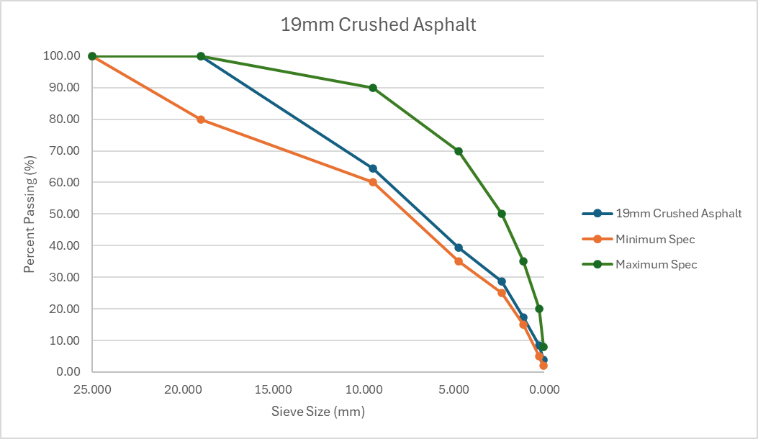
Figure 2. Relationship between percent passing (%) and sieve size (mm) for the average value of 19mm crushed asphalt compared to City of Kelowna specifications.

Table 3. 75mm crushed asphalt average percent passing and Kelowna specifications.
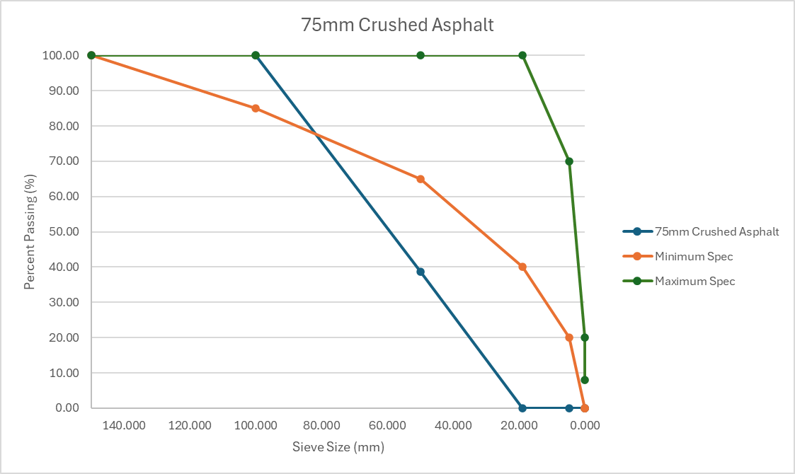
Figure 3. Relationship between percent passing (%) and sieve size (mm) for the average value of 75mm crushed asphalt compared to City of Kelowna specifications.

