Looking back, 2017 was defined by our community’s response to regional emergencies, water system integration and homelessness.

Flooding & fires
From May 4 through Sept. 11, we supported multiple regional Emergency Operation Centre (EOC) activations continuously for 131 days. Collectively, we worked with regional partners and other levels of government to deal with response and recovery for flooding, three forest fires, one apartment fire and Emergency Support Services for evacuees from the Cariboo and Nicola regions.

With more than $10.6 million in damages, the City will pay $3.3 million, with provincial government reimbursement for the rest.

Integrated water system
City Council adopted the 2017 Kelowna Integrated Water Supply Plan, outlining a new path forward for the delivery of domestic and agricultural water in Kelowna.

We initiated Phase 1 of the plan, which includes separation of agricultural and domestic systems in Southeast Kelowna and delivery of a sustainable water supply to that area’s water customers.
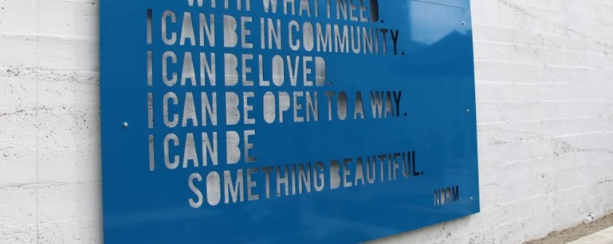
Addressing homelessness
Acting as a facilitator, we started the Journey Home Strategy and its task force, collaborating with more than 50 community groups and other levels of government to respond to immediate and emerging issues related to homelessness.

We established a new partnership with BC Housing and local service agencies for an extreme weather shelter and plans for a new Rapid Response Housing development for the homeless or those at risk of being homeless.
///

Other notable highlights from the year include:

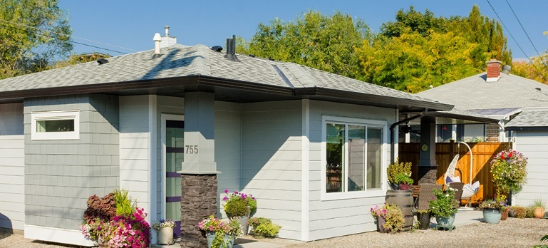
More housing options
- Implemented infill housing zoning to remove barriers for residential suites in homes and increase densities
- Provided 11 rental housing grants to build 1,000+ rental units
- Exceeded Official Community Plan (OCP) targets for development applications for urban/suburban and single family/multi-family homes.
- Completed a Housing Needs Assessment to provide a snapshot of housing today, identify gaps in the current housing stock, and forecast housing needs to 2040. This will guide the development of the Healthy Housing Strategy, and other master plan updates.

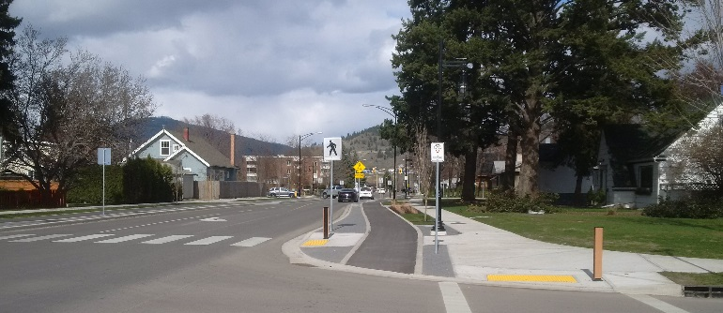
Expanding active transportation
- Initiated the Kelowna on the Move Strategy to address the evolving active transportation needs of our citizens, with the strategic vision expected to be delivered in 2019.
- Demonstrated ongoing commitment to improve cycling and pedestrian corridors with the completion of Phase 3 of the Ethel Street Active Transportation Corridor, which now stretches 1.3 km from Cawston Avenue across Harvey to Sutherland.

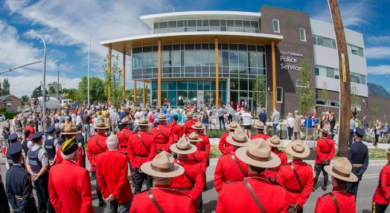
Enhancing community safety
- Completed the Kelowna Police Services building, providing a centralized headquarters for the RCMP.
- Supported the launch of the Police and Crisis Team (PACT) in partnership with Interior Health to have an RCMP member and mental health nurse duo respond to calls when an individual undergoing a mental health crisis is suspected, providing more timely care and reduced wait-times at hospitals.
- Kelowna Fire Department responded to more than 11,000 calls.

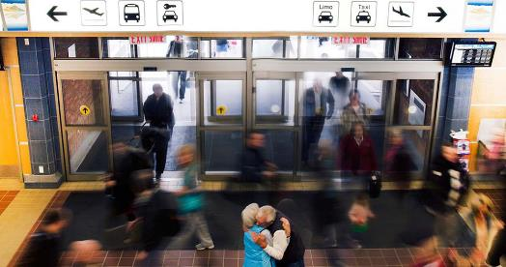
Encouraging business
- Expanded YLW’s services for traveler experience and efficiency with construction and renovations of the Outbound Baggage facility, Airport Plaza and departures lounge.
- Facilitated migration of companies to Kelowna and growth of existing employers via the City’s business arm, Enterprise Kelowna. Coordinated business visits with the Mayor, liaison services, partnerships with regional economic development organizations and growth of the City’s Dark Fibre Network.
- Launched the fourth year of the national artsVest™ program in Kelowna, with 21 organizations pre-approved for $50,000 of incentive grants. Total economic benefit to the local arts community over four years is expected to exceed $1 million.

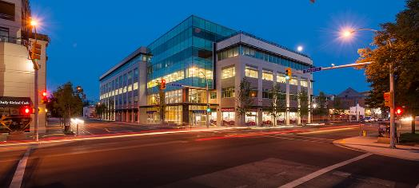
Building great places
- Continued the largest community conversation in Kelowna history, engaging with 4,000 residents, for Imagine Kelowna, a vision that will guide short- and long-term priorities over the next 25 years.
- Celebrated the opening of two significant downtown office buildings – the Okanagan Centre for Innovation and the Interior Health Authority headquarters, introducing hundreds of people to the downtown during work hours.
- Conducted public engagement and developed a plan for the future of the Capri Landmark urban centre.
- Completed the Parks Development Report for a focused assessment of undeveloped and underdeveloped parks to address the gaps on parks development.

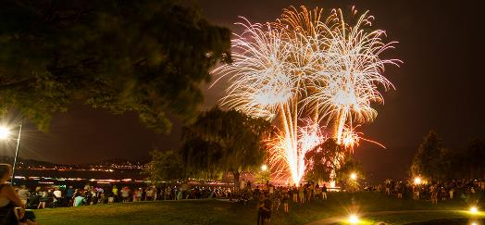
Fostering vibrancy & inclusivity
- Contributed to the nation-wide Canada 150 celebrations, alongside program partners, with community events throughout the year.
- Engaged the sport community in the development of a Community Sport Plan, based on Canadian Sport for Life (CS4L) principles to facilitate and promote quality sport in our community for years to come.
- Evaluated the suitability of 157 City parks and 76 City buildings to meet the needs of seniors, young children, and those with diverse abilities as part of the Community for All, Parks & Buildings Assessments report.

Protecting agricultural land
- Completed the industry supported, comprehensive update to the Agricultural Plan.
- Developed the Agricultural Compliance and Enforcement Strategy to target illegal farmland activity.
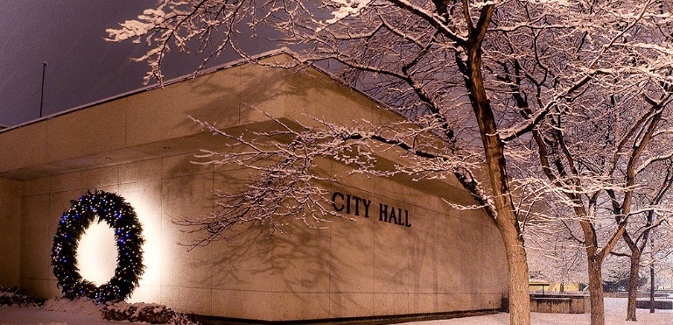
Managing City dollars
- Funded City projects and services from a variety of sources, with 71 per cent coming from sources other than taxation.
- Received more than $20 million in grant and government funding for various projects to offset tax impact.

Asking citizens
In the fall, we completed the 2017 Citizen Survey to gauge public satisfaction with municipal programs and services and to gain insight into citizen’s service priorities. 90 per cent of citizens say they are satisfied with the overall level and quality of services they receive from the City and 84 per cent say they receive good value for their taxes.

Our awards & recognition
Government Finance Officers Association’s Distinguished Budget Presentation Award for our 2017 Financial Plan

Government Finance Officers Association’s Canadian award for Financial Reporting for our 2016 Annual Report

PERC Award for Management Innovation and Ingenuity for our Strong Neighbourhoods Program

Community Institutional Project and Judge’s Choice Award for the Kelowna Police Services building

Smart21 Community of 2018 finalist

WorkSafe BC Certificate of Recognition with $190,000 premium rebate

Attachments:
2017 by the numbers (PDF)
2017 citizen survey results (web page)

